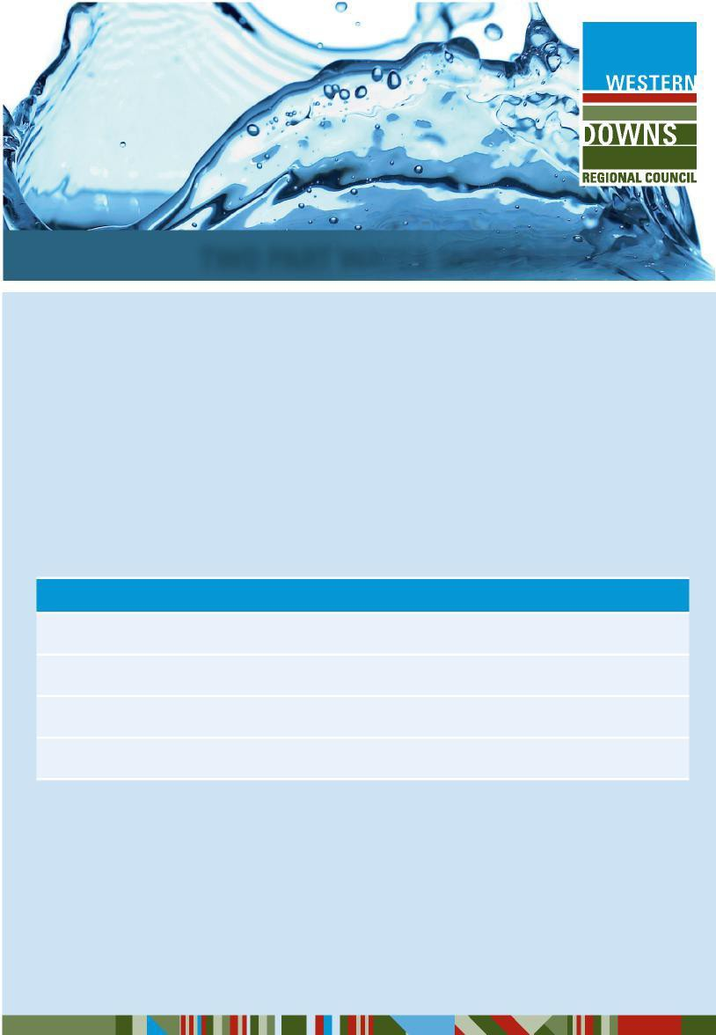

24/25**TWO-PART WATER TARIFF NOTICE**

Western Downs Regional Council wishes to notify its customers of amendments to its water pricing structure with the utilization of a two-part water tariff across all water supply schemes to offer a common pricing strategy to all communities.

An annual supply charge of **516.10** per standard (20 mm or 25mm) connection, **Part A** of the two-part tariff, is charged through the bi-annual rates notice.

**Part B** is the dollar amount calculated on the quantity of water consumed as stated in the standard consumption charges below and as charged through the bi-annual water bill.

The two-part tariff applies from 1 July 2024 and will apply to water consumption in the 2024/2025 financial year.

# Standard Consumption Charges

Bi-annual consumption **up to 125kL** will be charged at **$2.23 (per kilolitre)**.

Further Bi-annual consumption of **126kL to 250kL** will be charged at **$2.99 (per kilolitre)**. Further Bi-annual consumption of **251kL to 15,000kL** will be charged at **$3.70 (per kilolitre)**. Further Bi-annual consumption **greater than 15,000kL** will be charged at **$5.47 (per kilolitre)**.

The Communities of Jimbour, Kaimkillenbun, Kogan, Meandarra, Moonie, The Gums and Westmar which receive non-potable water will be charged 90% of the standard consumption charges above.

The Communities of Brigalow, Dulacca, Flinton and Glenmorgan which receive untreated surface water will be charged 75% of the standard consumption charges above.

The above published fees and charges are effective from 1 July 2024. No GST applicable.

# For more information please visit [www.wdrc.qld.gov.au](http://www.wdrc.qld.gov.au/) or contact Council on 1300 268 624.